**Introduction and Theory**

In the recent 2020 elections, Donald Trump lost which was a shock for many individuals. But considering recent events that have taken place in America, such as Black Lives Matter (BLM), it makes sense why Trump lost. These events increased awareness among many U.S citizens about the importance of inclusivity and breaking down the deep roots of racism.

In this report I am going to investigate if President Biden’s win was due to the recent events that highlighted the harmful effects of racism (such as the BLM movement). Did conservatives or liberals favor President Biden? Was President Trump’s loss primarily due to the occurrence of the BLM movement?

I hypothesize voters who supported the BLM movement favored President Biden while voters who were against the movement supported another candidate. I expect to see that the people who support the BLM movement will be liberals/democrats and come from a diverse ethnic background. On the other hand, voters who are against the BLM movement would be conservative/republicans and would have a predominantly white ethnic background.

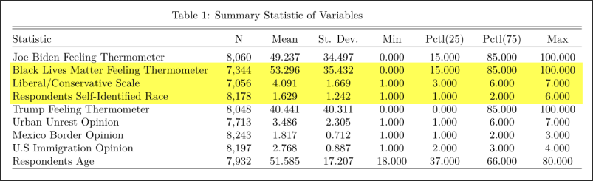**Description of Main Variables**

For my analysis I am using the data collected from the 2020 American National Election Study. I will be looking at the pre-election component of the study which contains a sample size of approximately 8000 individuals who represent the American adult population. Before I go on to give a detailed description of each variable I have included a summary statistic of each one in the table 1.

***Table 1****: A summary statistic of the variables used in this analysis. The variables highlighted in yellow are the main independent variables that I will be measuring.*

The output variable that I will be measuring is the “Joe Biden Feeling Thermometer”. This variable measures how “warm/cold” a respondent feels towards Joe Biden. ***Zero*** means that the respondent feels “cold” towards Joe Biden (they do not like him), while ***one-hundred*** means the respondent feels “warm” towards Joe Biden (they like him). ***Fifty*** means an individual feels neither “warm” nor “cold” towards Joe Biden (their feeling is neutral towards him).

Similarly, the independent variable “BLM Feeling Thermometer” works exactly like the “Joe Biden Feeling Thermometer”. ***Zero*** means that the respondent feels “cold” towards the BLM movement (they do not support the movement), while ***one-hundred*** means the respondent feels “warm” towards the BLM movement (they support the movement). ***Fifty*** means an individual feels neither “warm” nor “cold” towards the BLM movement (their feeling is neutral towards the movement).

Looking at table 1, you can see that the mean of the “Joe Biden Feeling Thermometer” is 49.24 which suggests that most of the respondents feel neutral towards Joe Biden. But the standard deviation of 34.5 tells us that most of the points are away from the mean (basically there is high variance in this variable so the mean would not be an accurate representation of the majority opinion about Joe Biden).

Similarly, the mean of the “BLM Feeling Thermometer” (53.3) suggests that all the respondents feel neutral towards the movement. But the standard deviation of 35.43 suggests that most of the points are away from the mean.

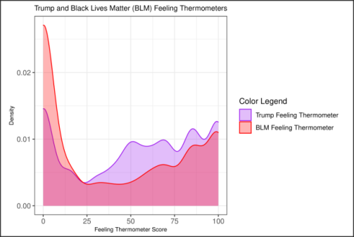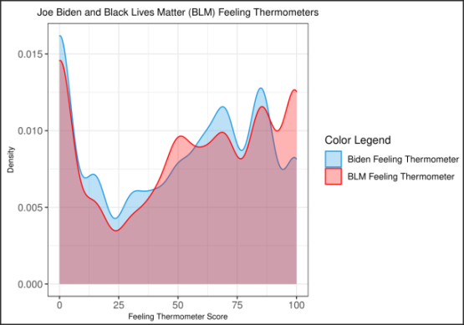Graph 1 explains this situation. You can see that there are many people who picked a low feeling thermometer for Joe Biden but at the same time there are a lot of people who picked a high feeling thermometer for Joe Biden. This is why the “Joe Biden Feeling Thermometer” had a large standard deviation. Graph 1 also compares the “Joe Biden Feeling Thermometer” with the “BLM Feeling Thermometer” and as you can see both graphs are identical in the sense that a lot of people who do not like President Biden do not support the BLM movement and a lot of people who support President Biden also support the BLM movement. But I did notice that around 95-100 percent there were more people who supported the BLM movement but did not like President Biden. This difference could represent a group of people who do not think Joe Biden is a good candidate to address the conflicts related to BLM.

***Graph 1***

I also decided to compare the “Trump Feeling Thermometer” with the “BLM Feeling Thermometer” and I noticed there were many respondents who put in a high score for Trump but the support for the BLM movement was way lower (this is why the purple shade covers most of the graph). When the score was 0-10 percent there were many respondents who did not support the BLM movement but there was not a high amount of respondents who gave Trump that low score. This suggests that many people who write down a low score for the BLM feeling thermometer most probably did so because they favor Trump or are conservative.

***Graph 2***

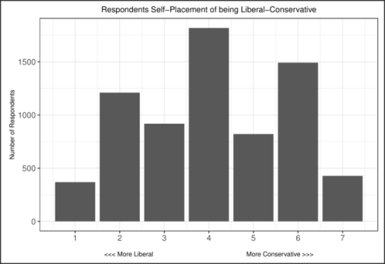The main objective of the research is to see if an individual’s preference towards BLM, their political standing on being liberal/conservative, and their race plays a role in their support towards Joe Biden. I have covered the variable that measures an individual’s preference towards the BLM movement. Now I will explain how the other 2 main variables are measured.

A respondents political standing on being liberal/conservative is determined by the question “Where would you place yourself on a liberal-conservative scale?” Individuals answer this on a 7-point scale where 1 is “Extremely liberal” and 7 is “Extremely Conservative”. Graph 3 highlights this difference. The average political standing that all respondents had were 4.09 which means that most of the respondents chose to be neutral (neither liberal or conservative). This is shown in graph 3 since most of the respondents picked number 4.

***Graph 3***

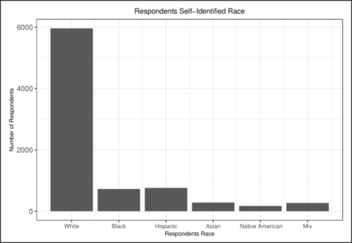A respondent’s race is determined by a 6-point scale. If they pick 1 they identify as white. 2 means they identify as Black. 3 means they identify as Hispanic. 4 means they identify as Asian. 5 means they identify as Native American. 6 means they identify with a mix of races. The average amount of respondents in this sample identify as white since the mean is 1.06. This can also be seen in graph 4. Including the weights in my regression and hypothesis tests would make sure each race is equally represented in our analysis.

***Graph 4***

**Description in Means**

The main relationship that I am interested in studying is how an individuals feeling thermometer score changes given certain factors such as ideology and race. To investigate the relationship I have made the “BLM Feeling Thermometer” variable into an indicator variable where 0 indicates that an individual does not support the BLM movement (a feeling thermometer score of anything less than 50). 1 indicates that an individual supports the BLM movement (a score of anything equal or greater than 50).

The graph titled “pooled” (this is in *graph 5*) displays the distribution of feelings towards Biden among the two groups mentioned above. The means between people who support and do not support the BLM movement are far apart from each other. This shows us that the level of support that one has for the BLM movement does play a huge role on an individuals feeling towards Joe Biden. But there are some people who do support the BLM movement and have a low score for Biden and there are some who do not support the BLM movement and gave Biden a high score. So the amount of BLM support is not a guaranteed factor in determining if one likes Biden or not. The mean rating for individuals who do not support the BLM movement is 20.79 and people who do support the BLM movement is 66.58. The probability of seeing a difference as extreme as 48.4 in our sample if the true difference in the population was 0 is < 0.01.

The center and right figures display a similar relationship for individuals who are conservative (5,6,7 on the ideology scale) and liberal (1,2,3 on the ideology scale). Individuals who identify as white (1 on race scale) and non-white (2,3,4,5,6 on race scale) are also taken into account in these graphs. These graphs show us the affect that ideology and race plays in an individual’s feelings towards Joe Biden.

**White conservatives** have a negative relationship since there are many people who give Biden a low score but very few individuals give him a high score. The number of people who do not support BLM drastically decreases as Biden’s feeling thermometer score increases but the purple line (people who do support BLM) has a more of a gradual decrease. This suggests that white conservatives who do not support the BLM movement strongly oppose of Joe Biden, whereas the BLM supporters like Biden a bit more. The extreme difference of 10.27 is much smaller than what was shown in the “pooled” graph. The probability of getting this difference if the true population difference was 0 is < 0.01.

Even though the current null hypothesis is still being rejected; that there is zero difference in the population for the mean feeling towards Biden for these two groups. Taking into consideration whether a respondent is conservative/liberal or white/non-white reduces ones feelings towards Biden reduces the relationship (that is the extreme difference get closer to zero or are smaller than the difference in the “pooled” graph) .

The relationship for **non-white conservatives** is similar to **white conservatives** except that the non-white conservatives who do support BLM show a higher average rating of Biden. This shows that race does play a role in determining ones support for Joe Biden. Even in you are a conservative but are non-white then there is a higher chance that you would show more support for Joe Biden. The extreme difference of 10.27 is much smaller than what was shown in the “pooled” graph. The probability of getting this difference if the true population difference was 0 is < 0.01.

The relationship for **white liberals** and **non-white liberals** is positive for both graphs. This is because you can notice an increase in the amount of ratings Joe Biden gets as the thermometer score increases. This can be seen in the purple line for both graphs (people who support BLM). The green line for both graphs does not change much (people who do not support BLM). The mean difference for both variables (21.96 for **white liberals** and 18.37 for **non-white liberals**) is not too big so this means that being a liberal white/non-white does not make a drastic change in terms of ones support for Joe Biden. So if you were a white or non-white liberal your main indicator which would show your support for Joe Biden would be if you support the BLM movement or not. The probability for getting an extreme difference of 6.59 if the true population difference was 0 is < 0.01 (this is for **white liberals**). The probability for getting an extreme difference of 3.65 if the true population difference was 0 is < 0.01 (this is for **non-white liberals**).

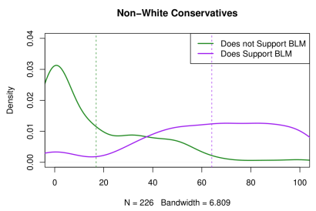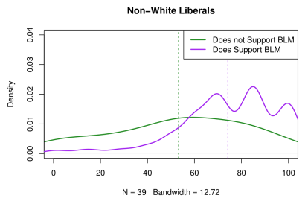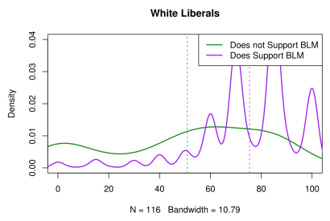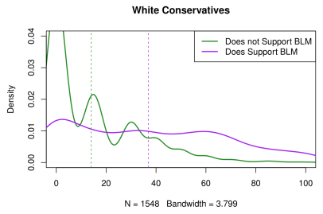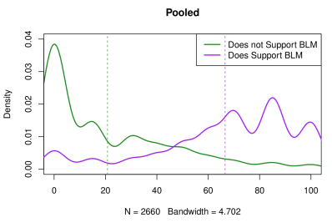

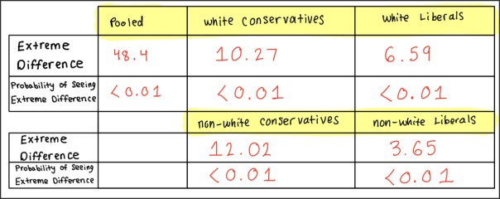

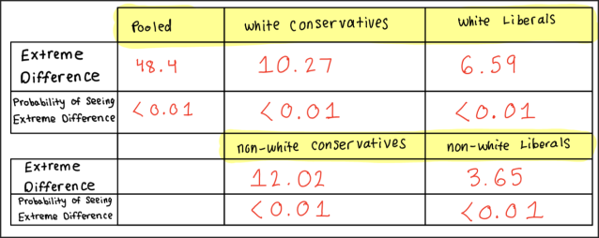

***Graph 5 Summary***

***Graph 5***

**Regression Analysis**

The difference in means analysis supports my hypothesis that BLM support, ideology, and race do impact the feelings one has towards Joe Biden. One drawback of the difference in means analysis is that it did not allow us to use control variables and it simplifies variables. These issues can be resolved through OLS regressions.

In the analysis I am treating ideology as a continuous variable. This means that the jumps in the scale (from "Extremely conservative" to" conservative ") are even. This is because the scale was presented as a 7 point scale, so it makes sense that individuals would see the movement between scales as being equal steps.

I am going to be keeping race as an indicator variable (as I did in the difference of means analysis). 1 means a respondent is white (1 on scale). 0 means a respondent identifies as non-white (2, 3, 4, 5, and 6 on scale). I am doing this because I wanted to categorize the race into 2 groups since that is what I have done in my analysis.

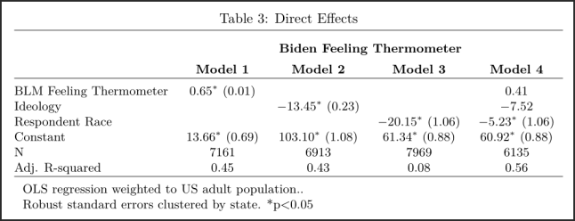Since the intensity of an election changes between each state this means that I might make errors in my regression that are correlated to states (BLM support, ideology, and race might predict better feelings in certain states where people are given incentives to participate in politics). Because of this, in all specifications below the robust standard errors are clustered by state.

Models 1-3 in Graph 6 displays the direct effects of BLM support, ideology, and race on feelings towards Biden.

***Graph 6***

**Model 1** shows the bi-variate impact of **BLM support** on feelings towards Biden. The relationship is positive which means that each time an individual increases one point in BLM support the score for Biden would increase by 0.65. A shift from 0 to 100 in BLM support would increase Biden’s support score by 65 points (0.65*100=65). **Model 2** shows the direct relationship between **ideology** and feelings towards Biden. This relationship is negative which means that a shift in the ideology scale would decrease Biden’s score by -13.45. Shifting from extremely liberal to extremely conservative would drop Biden’s score by -80.7. **Model 3** shows the bi-variate impact of race on feelings towards Biden. The relationship is negative which means that as an individual switches their race to non-white to white the support by Biden drops by -20.15. **Model 4** looks at the direct effect of all these variables while holding the others constant. A negative relationship still holds with the ideology and race variables but they have decreased significantly. The BLM thermometer variable has also decreased. The BLM thermometer variable had the smallest decrease which most probably means that BLM support is a good predictor of ones ideology and race. The relationships between the 3 key variables and feelings towards Biden are of a decent size which means I can reject the null hypothesis that the true relationships in the population are zero.

The main interest is to see how the relationship between BLM support and feelings towards Biden changes across levels of ideology and race. To do this I interacted 3 variables and the regression is presented in graph 7. The 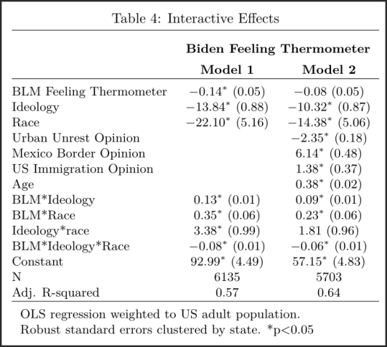coefficient on the interaction term shows how BLM support changes across levels of ideology (**BLM-Ideology** Coefficient). One unit increase in ideology means that BLM support increases by 0.13. The **BLM-Race** Coefficient shows that a one unit increase in race increases BLM support by 0.35. The **Ideology-Race** Coefficient shows that a one unit increase in race increases BLM support by 3.38. The **BLM**-**Ideology**-**Race Coefficient** shows that a one unit increase in race and Ideology decreases BLM support by -0.08. This shows that when Ideology and Race are looking at together they impact BLM support negatively. This can be shown in the difference of means graph, especially when you look at the “white conservative” graph. The probability of seeing an extreme interaction effect like this if the true interaction effect was 0 is < 0.01 (this means we can reject the null hypothesis).

***Graph 7***

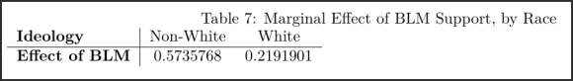The main interest is the effect of BLM support of Ideology and Race and the coefficients are not entirely helpful since it represents the effect of BLM support when ideology or race are equal to zero (which it cannot be). Graph 8 shows the effect of BLM support across ideology. For individuals who are very liberal BLM support has a positive effect on their support for Biden. A one unit increase in BLM support increases Joe Biden’s score by 0.74. This effect decreases as individuals become more conservative. When you move from the scale of 6 to “Very Conservative” the support for Biden goes from positive to negative. This can be seen in the difference of means graph for white conservatives and non-white conservatives who do not support BLM. Also, a one unit increase in BLM leads to a 0.57 score increase for Joe Biden among people who identify as non-white. The score increase for whites decreases a bit but is still positive.

***Graph 8***

Now looking back at the regression in graph 7 we can see that people, who hold negative opinions about how to deal with urban unrest, want to build the Mexican border, and want to Government to use a harsh immigration policy are more likely to be conservative and identify as white. What I found interesting is that as one age increases that the support for Biden increases by 0.38. Although this is not a huge score it suggests that as the younger generation gets older they would align with more liberal values and laws that accepts immigrants and reduces racism and violence.

**Conclusion**

The relationship between Joe Biden support and race, ideology, and BLM support is a complicated one. I observed that people who identify as white and are conservative are more likely to not support Joe Biden and vote for another political candidate (this could be Trump or someone else). Interestingly, non-white conservatives who support BLM are more likely to show support to Joe Biden bit non-white conservatives who do not support BLM would not show much support to Joe Biden.

For Liberals nothing changes much in regards to race. Whether you are a white or non-white liberal who supports the BLM movement then your support for Joe Biden will be high. If you are a white or non-white liberal who does not support the BLM movement your support for Joe Biden would be low but not as low as the conservatives.

A further look into this research might see how religion and other factor play into Joe Biden support.